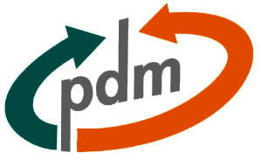

MP PDM TRAINERS GUIDE
TABLE OF CONTENTS
1. Introduction 3
2. Planning a training session 3
3. TPHR and Feedback collection 4
4. End user training structure 5
5. Training material database introduction 7
6. Structure of training materials 9
6.1. Introduction 9
6.2. Exercises 10
7. The System Help 10
8. Training environment 10
9. Other 11
9.1. VAL items 11
9.2. Translations 11
APPENDIX A: CHECKLIST FOR TRAINER AND TRAINING COORDINATOR 13

Introduction
The most important actions in order to arrange a successful training session are described in this document. This documents purpose is to give support and instructions to the PDM trainers. Appendix contains useful checklist.
Please contact Jussi Eskelinen (jussi.eskelinen@metso.com) or Aki Kokkinen (aki.kokkinen@metso.com) in case of additions or changes.

Planning a training session
In order to achieving a successful training, you should create a training plan. In training plan you should think at least these things:
- Contents of a course
- Schedule
- Used materials
- Used resources
- Implementation
- Audience analysis (initial knowledge, job description)
- Course goals
- "Plan B" for occasions if something goes opposite as planned
- Evaluation
To be contiuned….

TPHR and Feedback collection
TPHR (TietoPersona Human Resources) is a information system, which manages most of the information related to Metso Paper employees (e.g. salaries, competence data, taken courses/training). Every internal course has to be fed into the TPHR course management module.
The feedback from every PDM training session is collected into the Training feedback –Lotus Notes database. The database is created not only to collect feedback from PDM training’s but also from all training arranged in Metso Paper. Feedback is collected to evaluate the quality of PDM training sessions and to give information for further development.
Every business sites training coordinator will take care these actions so its important that you inform your training coordinator when you are arranging a PDM training session. You should give to him/her following information:
- Your name, site and department
- Course name and target group (It is recommended to use the similar course names with training modules represented in PDM training material database.)
- Course duration, dates and times, venue, prices (if there is),
- Names, e-mails and departments of the participants

Training coordinators:
Pia Ulmonen / Pansio
Anita Liiri / Järvenpää
Eero Lahtinen / Valkeakoski
Paula Perälä / Karhula
Leena Ture / Pori
Anu Felin / Hollola
Aki Kokkinen & Jussi Eskelinen / Others

End user training structure
PDM training structure for end users is planned to be as following:
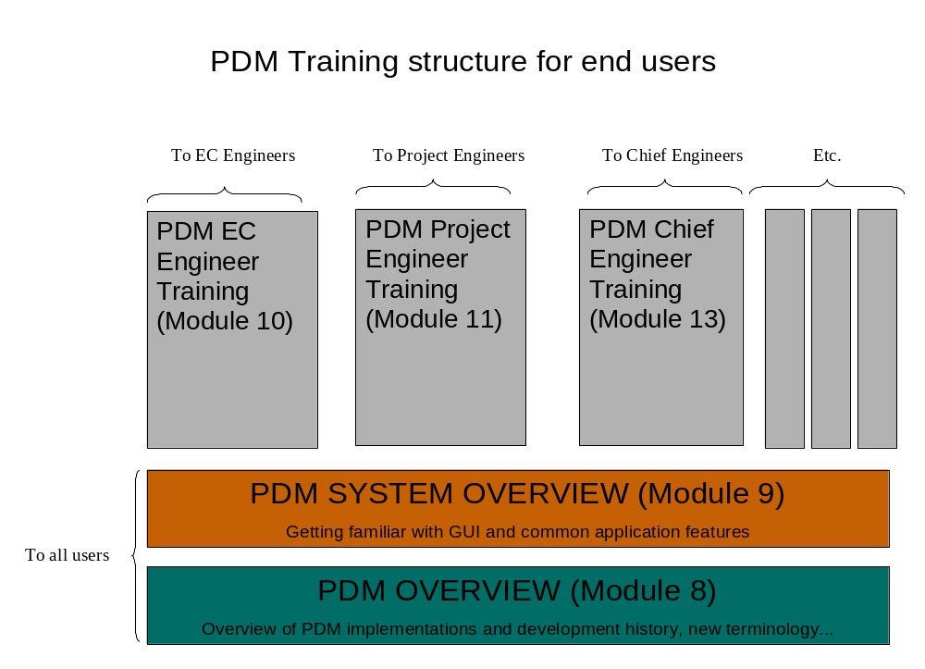
First trainees are introduced to overview of PDM in general: backgrounds, implementation and development history, new terminology etc. Next trainees are introduced to PDM system: GUI (Graphical User Interface), basic features, navigation, system help etc. After these common modules trainees participate the business specific training modules according their business role.
Training material database is created to maintain common training material for these training modules.

Training material database introduction
A PDM Training Material -Lotus Notes database has been created to support local (and global) PDM implementation training. The material is maintained by ECC. If you want to make additions in the PDM training material database please contact Jussi Eskelinen (jussi.eskelinen@metso.com) or Aki Kokkinen (aki.kokkinen@metso.com).
The database is divided into two main categories (see Figure 1):
- Templates and instructions
- Training material
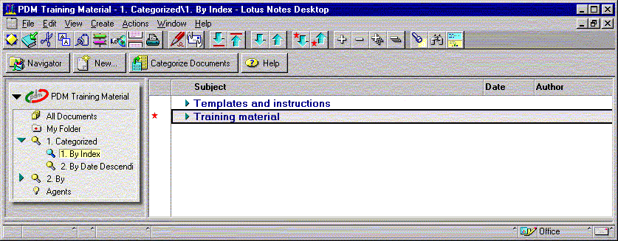
Figure 1: Main categories of the PDM training material database
"Templates and instructions" include all templates and instructions relevant to a PDM trainer (or in some cases to a trainee). The category includes also a document that contains links to other supporting databases.
"Training material" includes all the training materials made about Metso Paper PDM system. Furthermore, this category has been divided into subcategories (see Figure 2) according to common training modules. Under each training module you can find materials made by local implementation projects (abbreviation of current unit, e.g. PMM, COA, CAL, WIN).
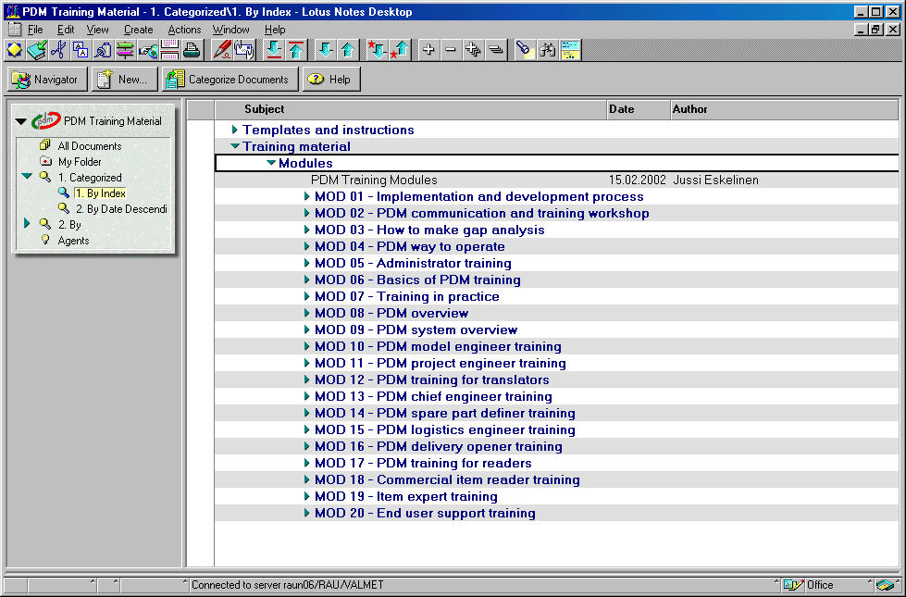
Figure 2: Materials listed according to training modules
The idea of the common training material is to provide extensive package of training material for local implementation. Modules 1-4 represents information packages for PDM implementation project members. Modules 5-7 contain material for local administrator and trainer training. Modules 8-9 represent overview material that is suitable for everyone who needs introduction for PDM. This overview information should be clarified to everyone before further trainings. Modules 10-19 represent parts of business roles in Metso Paper. Module 20 contains material about the tasks of a local key user.

Structure of training materials
PDM Training material database contains common and business configured training materials. Each trainer can use common material and/or tailor common material for own business needs.
PDM overview material is made with Microsoft Power Point. Slides include notes for trainers. Trainer chooses slides witch he/she thinks is appropriate for the audience.
PDM system overview material is made with Microsoft Power Point. Slides include notes for trainers. Trainer chooses slides that he/she thinks are appropriate for the audience.
Business role based training modules consist of introduction and exercises.

Introduction
Introduction material is made with Microsoft Power Point. It is a presentation material for trainer and also a supporting material for trainees.
Introduction material consists of:
- cover page (including name of the particular module)
- table of contents
- aims of the course
- introduction
- definition of new terminology
- description of MP business process using PDM
- representing other important issues
- references to exercises
- summary (how the aims have been reached)
Also see the template: MP_PDM_Module_introduction_V0_1.ppt

Exercises
Not ready.

The System Help
The System Help is one part of the PDM system and it's used as part of training material. The function and features to be used in the system are described in the exercises but the System Help provides the solutions in detail. Usernames or passwords are not needed in System Help.
URL to System Help is:
http://139.74.141.102:7002/metso/omentree/omentree.html

Training environment
There are three PDM application environments available: production, playground and training environments. All PDM trainings are held in PDM training environment. URL to training environment is http://139.74.141.102:7001/metso/. Environments must be configured for your business needs before you can start to use the environments (set usernames, roles, default values, legacy data, Baan connections etc.). If training environment is not yet configured for your business needs you must make a help desk request to global PDM help desk. Make business configuration help desk request for any environment by using structured MS Excel document. This MS Excel document and instructions how to use it can be found in PDM Application management - Lotus Notes Database on raun06 under the category 35 PDM Application Management and 35.03 Business Installations. For further particulars apply to Mikko Rahi (TE).

Other

VAL items
The possibly occurring problem concerning VAL items in training environment is that the weight information might be missing. Calculate weight -function won't work correctly and give sensible results. In these situations it is recommended to ask someone with Commercial Item Manager rights (or someone in Item request team) to add weight information to those VAL items that are used during the training session. However, training can be carried out without this information.

Translations
Because all the common material is created in English, it is possible the material needs to be translated into other language by your location's resources. Still, Metso Paper Enterprise Competence Center (ECC) provides some support to this matter (e.g. minor checkings). Also remember to use already written materials you can find in the PDM training material database.
APPENDIX A: CHECKLIST FOR TRAINER AND TRAINING COORDINATOR
ISSUES CONCERNING TRAINING SESSION | DONE
Book trainer
Book classrooms
Arrange refreshments for the course
Send invitations and training program to trainees
Gather training material (make translations if needed)
Copy training material to trainees
Create "plan B" for backup
Ensure you get help in case of problems during the training session (projector or network doesn't work…)
ISSUES CONCERNING TRAINING ENVIRONMENT
Check that the PDM training environment is configured for your business needs (see chapter 8)
Check that the Baan training company is configured for your business needs
Check the functioning of usernames in PDM and Baan
Check PDM training environment connections to selected training Baan company
Check the functioning of computers in classroom and network connection to training environment
Take care of the VAL item weights and statuses if needed (see chapter 9.1)
OTHER
Inform training coordinator in order to feed course data into TPHR system & course calendar and for collecting feedback. (see chapter 3)
If training causes costs gather invoicing addresses
Take care of the invoices

